**Third Party Signs and Traffic Accidents – Final Report**

**Shawn Mills - 304420**

**Introduction and Literature Review/Background**

The concept of distracted driving is certainly far from a new phenomenon. For as long as vehicles have been on roads, there have been distractions – audible and visual - for those behind the wheel. These distractions can come in many forms, including other vehicles, pedestrians, animals, advertisements, music, and most recently cell phones. While there have been an abundance of recent news stories and awareness campaigns towards the dangers of cell phones and texting, discussions surrounding the effects of excess signage are currently minimal by comparison.

The city of Toronto enacted its Sign By-law in 2010. Under these by-laws, signage is divided into two categories:

* First-party signs – those signs that are used to identify the business or service at the location
* Third-party signs – those signs that are used to advertise goods or services that are not related to the businesses on premises

Permits for third-party signs take about 10 days to be issued once the application is received and must be renewed every 5 years. Failure to acquire a permit before installing these signs results in a minimum $305 fine, court appearances, and all related costs of removing the signs. Larger signs and signs with digital displays are restricted to Commercial Sign Districts, whereas other signs may be allowed in Residential or Open Space Sign Districts.

Additional details on the by-laws can be found on this site:

<https://www.toronto.ca/services-payments/building-construction/sign-permits-information/general-sign-inquiries/>

Some examples of articles addressing signs as a driving distraction include:

**The role of roadside advertising signs in distracting drivers** - <https://www.researchgate.net/publication/222691471_The_role_of_roadside_advertising_signs_in_distracting_drivers>

The above article discusses an experiment with twelve participants in a driving simulator who were judged on their driving behaviours when presented with a street with no advertising signs and when presented with that same street with advertising signs added. The results showed more erratic driving behaviours during the simulation with advertising signs added.

**Digital signage is a distracted driving hazard** - <https://www.myparkingsign.com/blog/digital-signage-distracted-driving/>

The above article discusses an experiment that monitored driver eye motion (glances) as the drivers passed by a digital billboard on a highway. The results of this were compared to the driver eye motion when there were no signs present along that same highway. The results concluded that an increase in the number of glances were noted as the test subjects were passing the advertising sign regardless of the direction the vehicles were driven.

**Research Question**

Does the presence of third-party signs affect the volume of traffic accidents in Toronto?

**Data and Description**

The first step in performing the analysis was to gather relevant datasets. After some review, the following datasets were selected:

**Third Party Signs Inventory**: <https://www.toronto.ca/city-government/data-research-maps/open-data/open-data-catalogue/business/#9b6f952e-52d7-1fc4-51f6-4ad6bc913218>

* This dataset provided the locations of all licensed third-party signs in Toronto.

**Toronto Police Service Public Safety Data Portal**: <http://data.torontopolice.on.ca/datasets/ksi/data>

* This dataset provided details on the traffic collisions throughout Toronto.

**SimplyAnalytics – Census Tracts and Demographic Data**:

<https://simplyanalytics.com/>

* This dataset provided the appropriate level of geographic detail for comparing the sign and traffic collision data. As well, it provided helpful demographic data in each census tract.

**Methodology**

The analysis made extensive use of Geospatial analytics due to the requirements of the research question. In order to answer the question, the location of the signs relative to the location of the traffic collisions must be known. Once this was in place, a technique known as Geospatial Autocorrelation was used to uncover the geographical relationships between the signs and collisions. Through this methodology, answers to the following would be uncovered:

1. Is there a relationship amongst the placement of the advertising signs themselves?
2. Is there a noticeable relationship between the number of traffic collisions surrounding the locations of the advertising signs?
3. Is there a demographic influence on the sign placements and, by extension, the number of related traffic collisions?

The following python (version 3.6.8) libraries were used for this analysis:

* Pandas 0.25.0
* Numpy 1.16.4
* Xlrd 1.2.0
* Matplotlib 3.1.1
* Seaborn 0.9.0
* Geopandas 0.5.1
* Shapely 1.6.4.post1
* Fiona 1.8.4
* Pycrs 1.0.1
* Pysal 2.0.0

**Results**

First step – standardize csr

Visualize the locations of signs and collisions

Spatial Autocorrelation results:

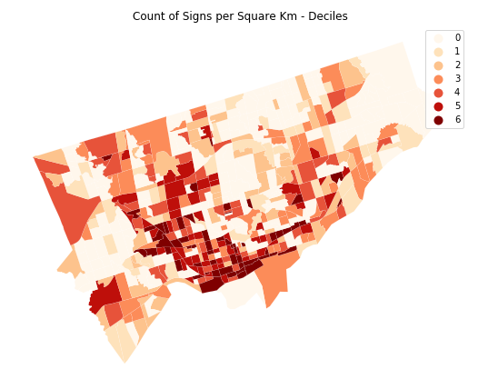

Spatial Similarity – mention weights

Attribute Similarity – spatial lag, used to measure attribute similarity (in this case Signs per Square Km)

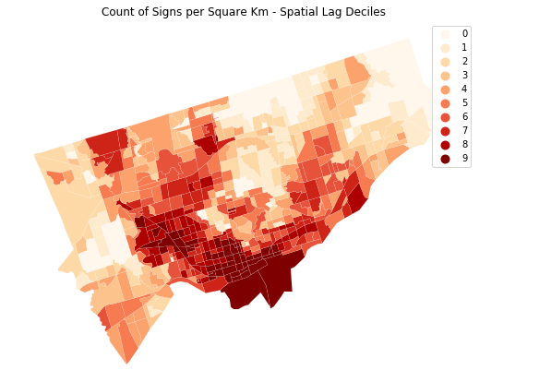

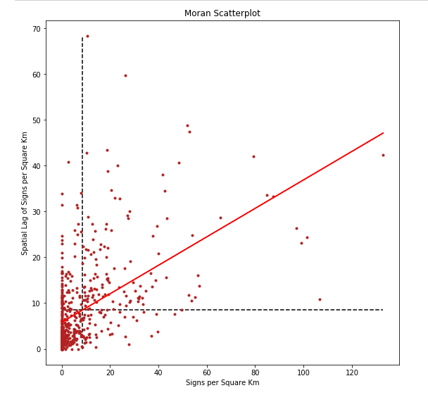

Local Autocorrelation Statistics

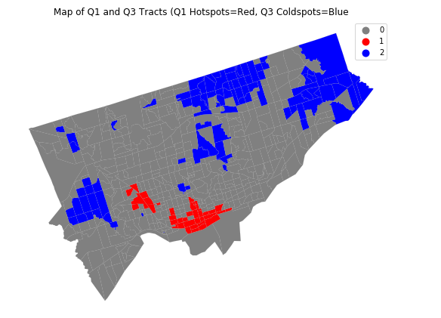

Spatial Autocorrelation – Traffic Accidents per Sign per Square Km

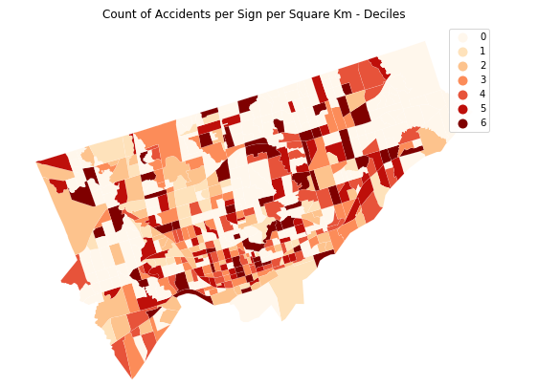

Attribute Similarity – Spatial Lag

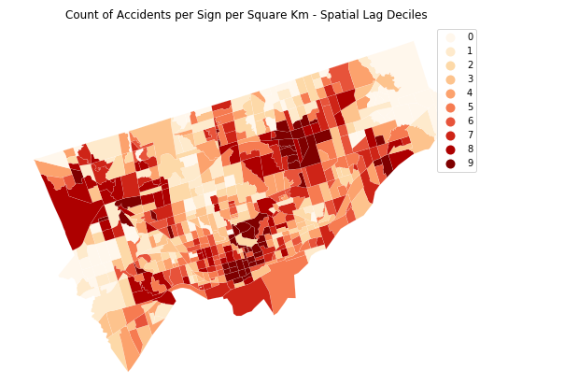

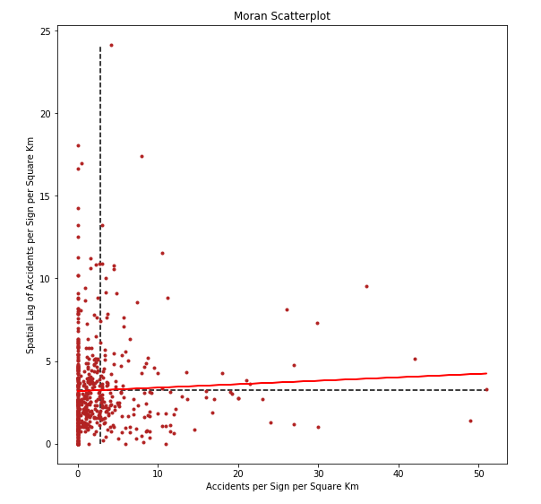

Local Autocorrelation

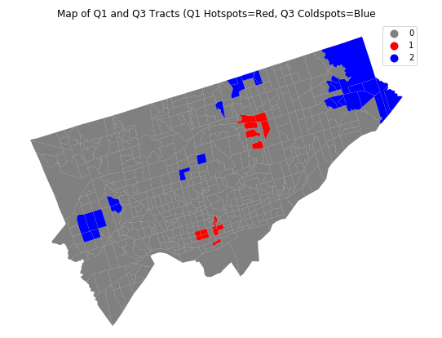

Spatial Autocorrelation – Traffic Accidents per Sign per Km – Above Average Population Count Census Tracts Only

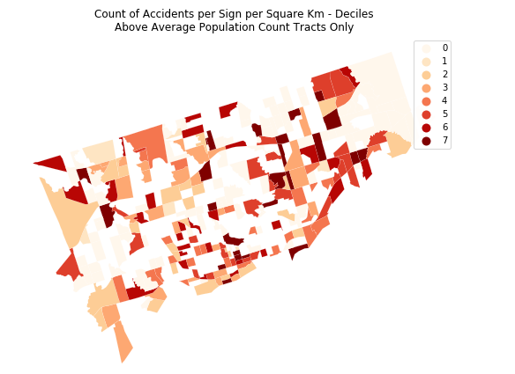

Attribute Similarity – Spatial Lag

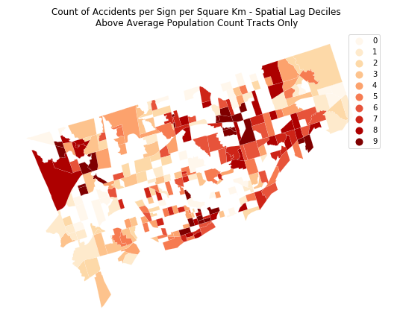

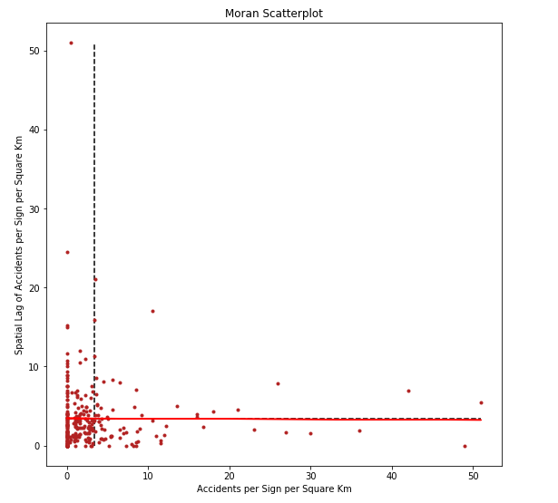

Local Autocorrelation – this reveals the problem with restricting the results to only areas with higher than average population:

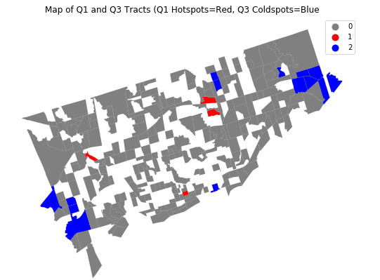

Referencing the following tutorial - <https://www.datacamp.com/community/tutorials/geospatial-data-python>

- results - fairly small

- conclusion - likely where the meat of the report will end up